5th Grades – UNIT 6: MOVIES TEST

1.Heatcliff: Do you like comedies?
Fırat: No, I don’t.
Heatcliff: Well, let’s watch an animation.
Fırat: Ok. What is the name of the movie?
Heatcliff: __________
A. It’s about animals.
B. It’s an adventure.
C. It’s Ice Age 4.
D. It’s at 7 p.m
2. My favourite movie is Star Wars. It’s about space. It’s ___________
A. animation C. comedy
B. cartoon D. sci- fi
3. Catherine: Let’s watch Titanic.
Deniz: Ok. _______________?
Catherine: It’s about a big ship.
A. What’s the name of the movie?
B. What is it about?
C. Where is it?
D. What time is it on?
4. Hangi eşleştirme yanlıştır?
A. name of the movie Hachiko
B. characters a dog and a professor
C. date 7 p.m
D. place Beykoz Cinema
5. Farklı olanı işaretleyin.
A. strong C. honest
B. brave D. cartoon
6. What is Twilight about?
A. It’s at the Space Cinema.
B. It’s on June, the 5th
C. It’s about vampires.
D. It’s a horror movie.

7. Hangi eşleştirme yanlıştır?
A. interesting – sıkıcı
B. exciting – heyecan verici
C. funny – eğlenceli
D. fantastic – harika
8. I like watching Kemal Sunal’s movies. I think they are ________.
A. cartoon
B. funny
C. animation
D. boring
9. I don’t like watching romance. I think it’s very _____.
A. exciting C. boring
B. interesting D. fantastic
10. Hangisi diğerlerinden farklıdır?
A. animation C. action
B. science- fiction D. exciting
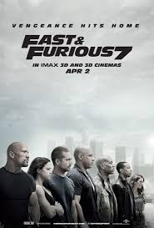
11. I like action movies.
I think they are _____
A. boring
B. frightening
C. scary
D. interesting
12. Menda: Do you want to go to the cinema?
Nancy: Yes, ofcourse.
Menda: Ok. Let’s buy ________ for Madagascar.
Nancy: Ok.
A. animation movie C. Çubuklu Cinema
B. tickets D. brave
13.

Resme göre cevaplayın.
She is very _________.
A. funny C. ugly
B. helpful D. evil
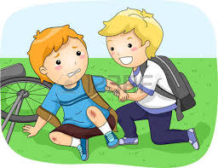
14.

Resme göre cevaplayın.
He is very _________.
A. scary C. funny
B. boring D. friendly
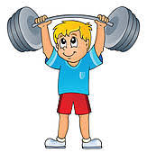
15.

Resme göre cevaplayın.
He is very _________.
A. strong C. friendly
B. honest D. helpful
16.
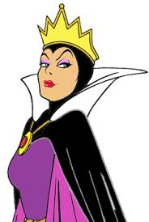
She is from the movie Snow White.
She treats everyone badly.
She is an ________ character.
A. funny
B. evil
C. friendly
D. honest
17.

Spiderman can lift cars. I think he is very _______.
A. honest C. strong
B. ugly D. evil
18.

Pinokyo sometimes tells lies. He isn’t ________.
A. brave C. beautiful
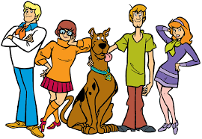
B. honest D. strong
19.

Scooby Doo has lots of friends. He is ________.
A. strong C. friendly
B. ugly D. evil
20.

Garfield always sleeps. He is very ___________.
A. handsome C. hardworking
B. beautiful D. lazy

Burçin BAYDAŞ
ELT Teacher

