KARKUCAK SECONDARY SCHOOL
2nd TERM 2nd WRITTEN EXAM for 6th GRADERS
Name & Surname: Class & Number: MARK:

ANSWER THE QUESTIONS (SORULARI CEVAPLAYIN)
1-2-3. Soruları aşağıdaki görsele göre cevaplayın.
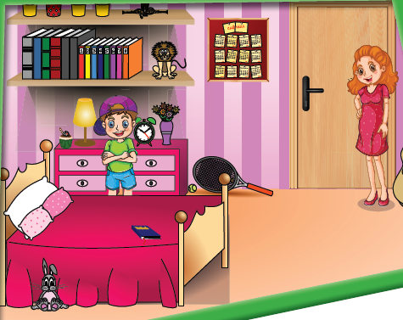
1- Where is the rabbit?
A) It is in front of bed.
B) It is near the bed.
C) It is under the bed.
D) It in on the wall.
2- Where is Mustafa?
A) He is next to his mother.
B) He is under the bed.
C) He is in front of the door.
D) He is between drawers and bed.
3- Where is the racket?
A) It is on the bed.
B) It is between the door and drawers
C) It is next to the rabbit.
D) It is under the shelves.
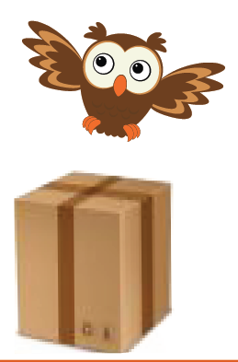
4- The owl is ______the box.
A) on
B) under
C) over
D) between
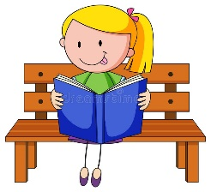
5- Şerife ______ two boks last week. She is a real bookworm.
A) readed
B) reads
C) ready
D) read

6- I am a waiter. I can _____.
A) sell goods
B) pull out teeth
C) serve drinks
D) look after ill people

7- Choose the best answer.
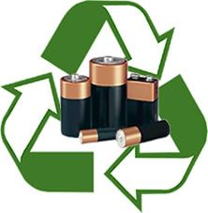
A) recycle batteries
B) cut down trees
C) turn off the lights
D) unplug the TV

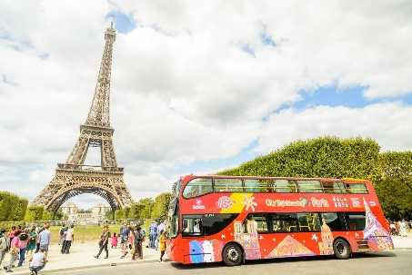
8- We go ______ every day on our bikes.
A) fishing
B) trekking
C) sightseeing
D) sailing

9- I am a tailor. I can ____.
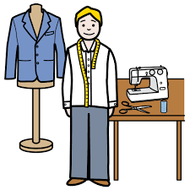
A) build roads
B) grow fruit
C) cut hair
D) sew fabric

10- You can learn rafting in Çoruh _____.
A) seaside B) mountain
C) river D) lake

11- We want to save energy so we should ____.
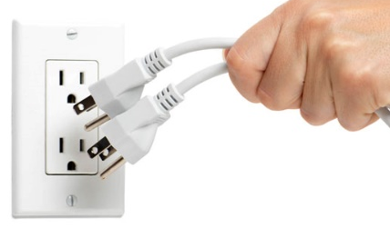
A) unplug the TV
B) throw rubbish
C) turn off the lights
D) harm animals

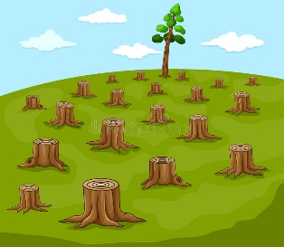
12 – If you want to protect the environment, we shouldn’t ____.
A) save energy
B) turn off the lights
C) cut down trees
D) waste water

13- I ____ books from the library on Mondays.
A) buy B) read
C) play D) borrow

14- Ahmet Yasin didn’t ___ his mother yesterday.
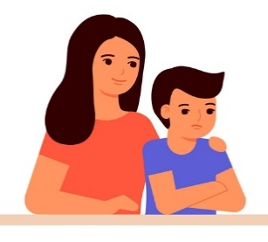
A) helped
B) helps
C) help
D) helping

15- We shouldn’t ______.
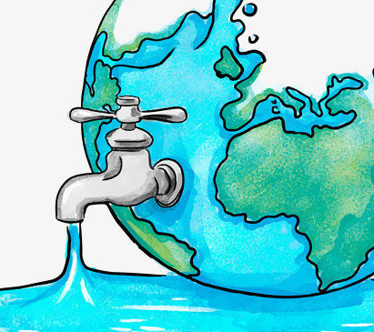
A) waste water
B) harm animals
C) recycle batteries
D) save energy

16- Kemaleddin and Esma _____ snowball last week.
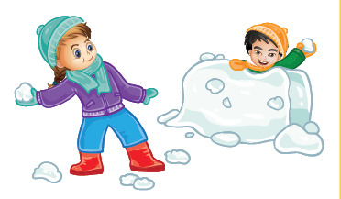
A) played
B) playing
C) play
D) plaied

17- Faruk ______ fruits last summer.
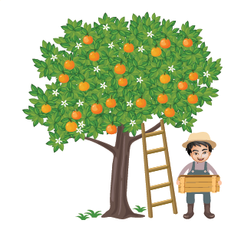
A) picks
B) picked
C) pick
D) picking

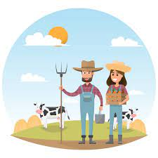
18- I am a farmer. I can_____.
A) sew fabric
B) serve food
C) cut hair
D) grow fruit

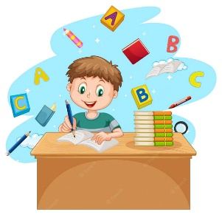
19- Efe came home yesterday and ___ his homework.
A) doing
B) does
C) did
D) do

20- The mechanic is ____ the car.
A) behind
B) under
C) next to
D) in front of

Her doğru cevap 5 puandır.
Ali AKDERE

