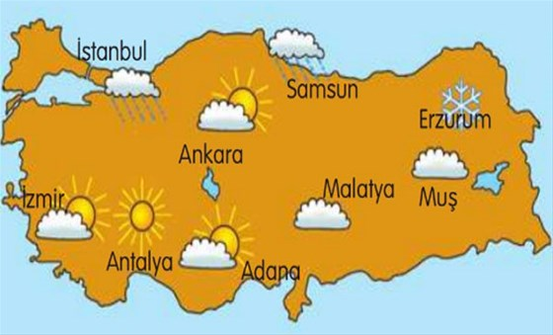

1. How is the weather in Adana?
……………………………………………………………
2. How is the weather in Erzurum?
……………………………………………………………
3. How is the weather in Samsun?
……………………………………………………………
4. How is the weather in Antalya?
……………………………………………………………
5. How is the weather in İzmir?
……………………………………………………………
6. How is the weather in Muş?
……………………………………………………………
7. How is the weather in İstanbul?
……………………………………………………………
8. How is the weather in Ankara?
……………………………………………………………
9. How is the weather in Malatya?
…………………………………………………............

1. Is it rainy in İstanbul?
…………………………………………………………………
2. Is it hot in Erzurum?
………………………………………………………………
3. Is it partly cloudy in Adana?
…………………………………………………………………
4. Is it sunny in Muş?
……………………………………………………………………
5. Is it windy in Samsun?
…………………………………………………………………..
6. Is it sunny in Antalya?
…………………………………………………………………..
7. Is it cloudy in Malatya?
……………………………………………………………………
8. Is it foggy in İzmir?
…………………………………………………………………
9. Is it stormy in Ankara?
…………………………………………………………………..

