Unit 1 Life Word List

After × Before :Sonra ×Önce
After that:bundan sonra
Arrive home :eve varmak
Aunt :teyze,hala
Best friend :en yakın arkadaş
Break time :ara,tenefüs
Chess club :satranç kulübü
Come home :eve gelmek
Cooking :yemek pişirme
Date :tarih
Do homework :ödev yapmak
Eat :yemek yemek
Finish all the homework :tüm ödevleri bitirmek
Get dressed :giyinmek
Get ready :hazırlanmak
Get up early :erken kalkmak
Give :vermek
Go back home :eve dönmek
Go to bed:yatmak
Go to school:okula gitmek
Go to step dance class:step dans dersine gitmek
Have a busy weekend :yoğun bir hafta sonuna
sahip olmak
Have breakfast:kahvaltı yapmak
Have dinner :akşam yemeği yemek
Have lunch :öğle yemeği yemek

For 6th Grade

Help dad:babaya yardım etmek
Listen to teacher carefully:öğretmeni dikkatlice dinlemek
Little brother :küçük erkek kardeş
Life:yaşam
Parents :ebeveyn (anne/baba)
Play football:futbol oynamak
Play volleyball :voleybol oynamak
Rest :dinlenmek
Run errands :ev işi yapmak
Say bye:veda etmek
School garden :okul bahçesi
Sixth grade :6.sınıf
Sleepy :uykulu
Start:başlamak
Student :öğrenci
Take a nap:şekerleme yapmak
Take care of the pet:evcil hayvanla ilgilenmek
Take folk dance course:halk oyunları kursu almak
Take English course:İngilizce kursu almak
Traditional :geleneksel
Visit grandmother:büyükanneyi ziyaret etmek
Wait:beklemek
Wake up :uyanmak
Watch cartoon :çizgi film izlemek
Write diary :günlük yazmak

Important Expressions &Sentences

Do you have a busy weekend? :Yoğun bir hafta sonuna mı sahipsin?
Do you go to step dance class after school ? Okuldan sonra step dans sınıfına gidecek misin ?
Does your sister run errands at home ? :Kızkardeşin evde ev işleri yapar mı ?
What do you do after school? : Okuldan sonra ne yaparsın?
What does your best friend do at break time ?:En yakın arkadaşın tenefüste ne yapar?
What is the date today ? : Bugünün tarihi nedir ?
What time is it? /What is the time?:Saat kaç?
What time does your school finish? : Okulun saat kaçta bitiyor?
What time does your little brother attend chess club? :Küçük erkek kardeşin satranç kulübüne saat kaçta katılacak ?
When do you visit your aunt ?:Teyzeni ne zaman ziyaret edersin?
When is your English lesson ? :İngilizce dersin ne zaman ?
Which of the activities on pages 10 and 11 do you do after school?: Okuldan sonra sayfa 10 ve 11 deki aktivitelerden hangisini yaparsın?

THE SIMPLE PRESENT TENSE

● USAGE

-We use this tense while talking about daily routines ,habits and activities done everyday.

Examples :

I wake up at seven o’clock in the mornings .
I take a nap after school.
I take care of my cat everyday .

-We use this tense while talking about likes and dislikes .

Examples:

I like playing football at the weekend ( like )
I don’t like running errands. ( dislike )

● FORM

- Affirmative Sentence - Negative Sentence

I  You  We  They | have breakfast at 8 o’clock  study English everyday.  go to step dance course on Fridays.  visit their grandmother at the weekend.
He  She  It | drinks tea in the evenings .  goes shopping at the weekend  eats a banana everyday.
I  You  We  They | don’t help my mom  don’t take English course  don’t go to bed late  don’t go to school | in the evenings.  everyday.  at nights.  at the weekend.
He  She  It | doesn’t take care of his dog  doesn’t have breakfast  doesn’t like swimming | in the morning.  on the weekdays.  everyday

Note: Özne “I , you , we , they “ ise fiil yalın halde Note : Özne “ I ,you ,we ,they “ ise olumsuz cümlede
kullanılır.Eğer özne “ he,she ,it “ ise fiil “-s,–es,-ies“ don’t ,eğer özne “ he-she –it “ ise doesn’t kullanılır.
takısı alır.

- Interrogate sentence (Soru cümlesi )

Do | I  You  We  They | brush my teeth everyday ?  have lunch at school?  do homework every evening ?  go to the cinema on Sundays ? | Answers  Yes, you do.  Yes,I do.  Yes,you do.  No ,they don’t .
Does | He  She  It | play football at the school garden ?  eat fruits everyday?  climb a tree? | Yes,he does.  No,she doesn’t.  Yes,it does.

Note: Özne “ I,you,we ,they “ ise cümlenin başında “ do “ ,eğer özne “he,she,it “ ise “does”kullanılır.

● SPELLING RULES ( Heceleme kuralları)

- Çoğu fiil “–s “ takısı alır .

My mother cooks delicious meal.
She comes home at 9:00 p.m in the evenings.

- “-ch,- sh,- ss, - o “ ile biten filler “es” takısı alır.

My brother watches TV every morning.
My school finishes at half past four.
Julia goes to traditional folk dance class every Saturday.

- Fiil “-y” ile bitiyorsa ve “-y “ den önce sessiz bir harf varsa “ y “ düşer ve fiile “-ies “ takısı eklenir.

Cansu studies English everyday. study – studies
Our baby cries every night. cry - cries

- “have “ fiili düzensizdir. “s” takısı aldığında have “ has “ olarak yazılır.

I have breakfast every morning.
She has breakfast every morning.

● TELLING THE TIME

We use this question “ What time is it? / What is the time ? ” by asking the time.

O’CLOCK  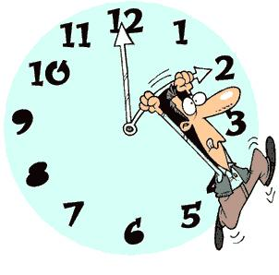  It is two o’clock . | HALF PAST  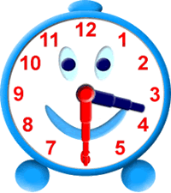  It is half past three  It is three ,thirty | QUARTER PAST  It is quarter past ten  It is ten ,fifteen .
PAST  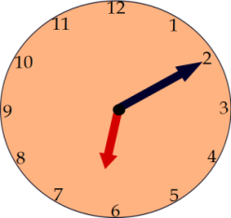  It is ten past six.  It is six,ten. | QUARTER TO  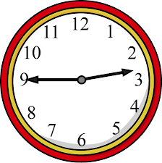  It is quarter to three.  It is two ,forty-five. | TO  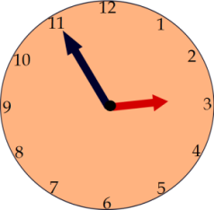  It is five to three .  It is two ,fifty-five

Prepared by

Ali AKDERE
English teacher

