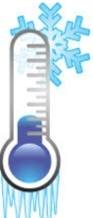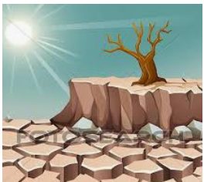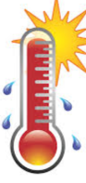 **WEATHER**

1. 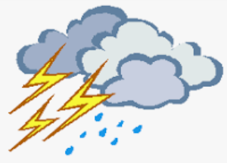_______________ 2. ________/_______ 3. _________/__________ 4. _________________ 5. ____________________ 6. _________

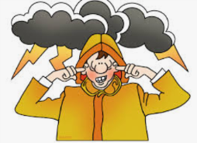

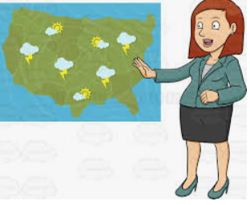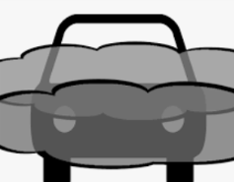7. ________________ 8. ________________ 9. ____________________ 10. ________________ 11. __________________ 12. ________

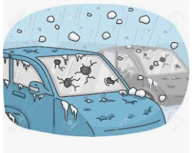

13. _______________ 14. _______________ 15. __________________ 16. ______________ 17. _____________________________

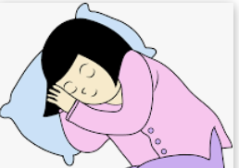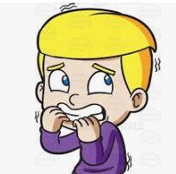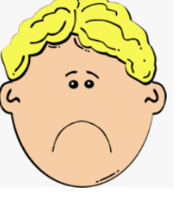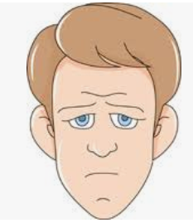 **EMOTIONS**

1. _________________/ 19. ________________ 20. ____________ 21. ______________ 22. ________/ 23.________ 24.______________

_________________ _____________