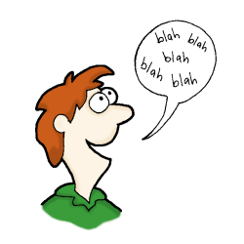 **All About Me**

My name is …………………………………

I am …………… years old.

I am a student.

I can spell my name. ……………………………

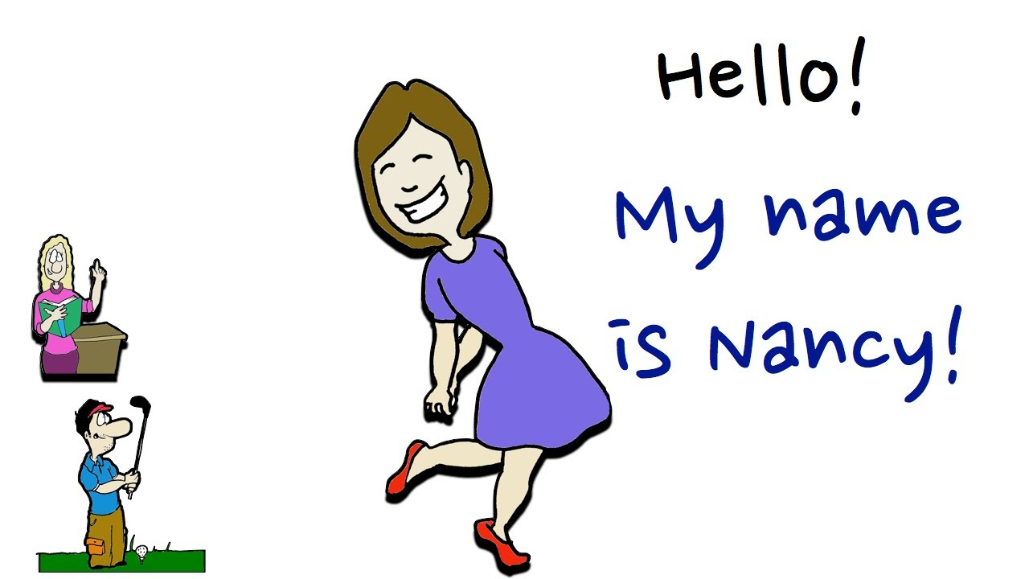 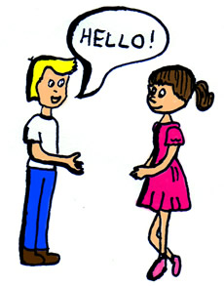

 **All About Me**

My name is …………………………………

I am …………… years old.

I am a student.

I can spell my name. ……………………………

 

 **All About Me**

My name is …………………………………

I am …………… years old.

I am a student.

I can spell my name. ……………………………

 

 **All About Me**

My name is …………………………………

I am …………… years old.

I am a student.

I can spell my name. ……………………………

 

 **All About Me**

My name is …………………………………

I am …………… years old.

I am a student.

I can spell my name. ……………………………

 

 **All About Me**

My name is …………………………………

I am …………… years old.

I am a student.

I can spell my name. ……………………………

 