***5. SINIF YABANCI DİL***

**1. 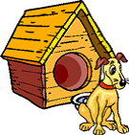Where is the dog?**

**It is ………………..house.**

a) in b) on

c) under d) in front of

**2) She is in the _________.**

**[](http://www.google.com.tr/imgres?q=library+clipart&hl=tr&biw=1280&bih=652&tbm=isch&tbnid=xJo7DNAP-7HVKM:&imgrefurl=http://www.clipartheaven.com/show/clipart/education_&_schools/cartoons/girl_in_library_3-gif.html&docid=Hzw6Qc8rdTWeYM&imgurl=http://www.clipartheaven.com/clipart/education_&_schools/cartoons/girl_in_library_3.gif&w=490&h=587&ei=sWkAT_iNDMnA8QOBlo39DA&zoom=)a)** canteen **b)** library

**c)** hospital **d)** bank



**3) I …………… swimming.**

**a)** like **b)** can

**c)** doesn’t like  **d)** don’t like

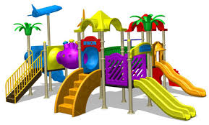**4) Resimlerde hangisi yoktur ?**



**8**

**9**

a) mosque b) stationery

c) playground d) pharmacy

**5**)

**10**

**a)** Classes start at 8:30.

______________.

**b)** I catch the school bus at 8:00.

**c)** I get up at 7:00.

**d)** I have breakfast

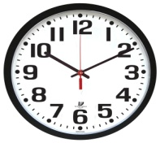**6) What time is it?**

A) It’s ten o’clock

B) It’s ten to ten

C) It’s ten past ten

D) It’s quarter past ten

**7) Which lesson do you have?**

1. Maths
2. Turkish
3. Physical Education
4. Social Science

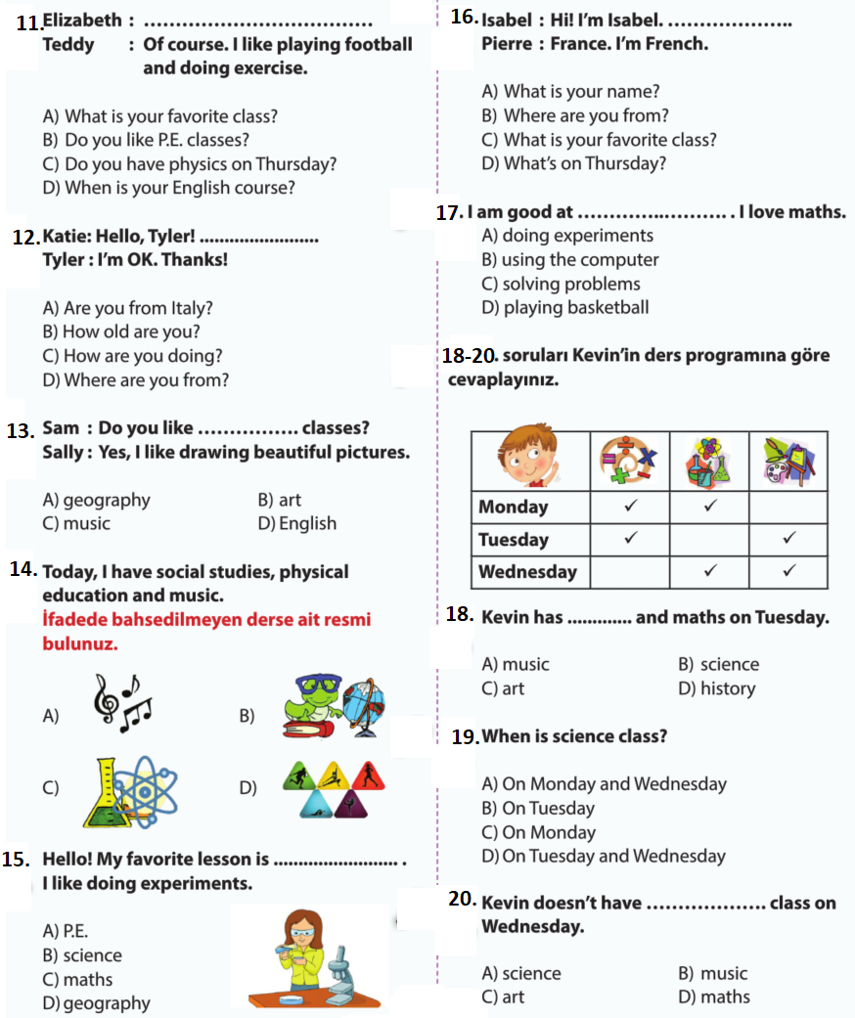

**8-9-10.**

ALİ AKDERE