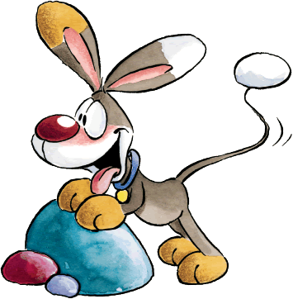

- I’m going to visit my granny in the afternoon.
- Are you busy tomorrow morning?

- I’d like to but I can’t.
- Would you like to come over tonight?
- Yes, I love them.
- Great, thanks.
s
- I’d like to see a play at the theatre.
- Well, we can watch an animation instead.
- I like romances.
- Nothing special.
- That would be great. I love music.
- No, thanks. I don’t like it.
- OK. I’ll take you after dinner.
- Yes, I would. What was the address?
- No, not at all. I don’t have any plans.
- Great idea. I like movies.
- Mostly thrillers.
- Do we have another choice?
- Would you like to see a movie?
- Would you like a cup of coffee?
- Would you like to come to the concert with me?
- How are you doing?
- Would you like to join us?
- Do you enjoy watching sci-fi movies?
- Do you have any plans for the afternoon?
- What are you going to do this evening?
- Will you come and pick me up?
- What do you want to do tonight?
- Do you like comedies or romances?
3. What type of movies do you have?

1 | 2 | 3 | 4 | 5 | 6 | 7 | 8 | 9 | 10 | 11 | 12 | 13 | 14 | 15

Answer Key
1 | 2 | 3 | 4 | 5 | 6 | 7 | 8 | 9 | 10 | 11 | 12 | 13 | 14 | 15
E | F | C | K | M | G | J | A | O | B | N | I | H | D | L

