Answer the questions using the information given in the brackets.
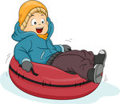 |  | 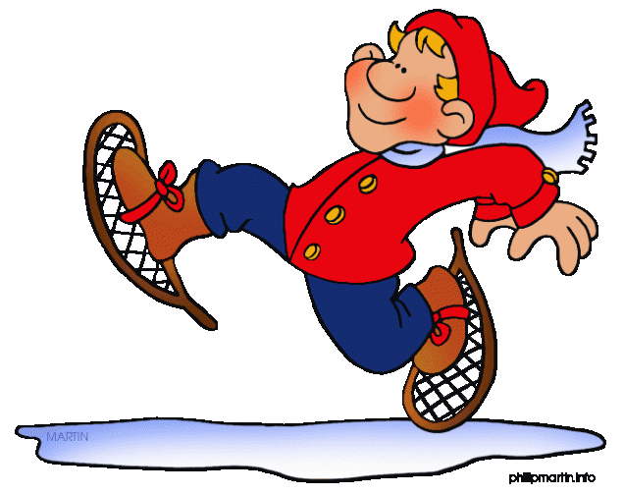
How often does Jim go snow tubing? (three times a year)  ______________________  ______________________  ______________________ | How often does Bill go zorbing? (hardly ever)  _______________________  _______________________  _______________________ | How often do you go snowshoeing? (never)  _______________________  _______________________  _______________________
How often does she hang out with her friends? (always)  ______________________  ______________________  ______________________ | How often does she read stories? (every night) ______________________  ______________________  ______________________ | How often do they paint pictures? (usually) ______________________  ______________________  ______________________
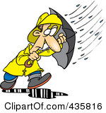  How often does it rain n Rize? (often)  ______________________  ______________________  ______________________ | How often do they eat out? (sometimes) ______________________  ______________________  ______________________ | How often does Oliver play tennis? (once a week)  ______________________  ______________________  ______________________
How often do you get up early? (5 times a week) ______________________  ______________________  ______________________ | 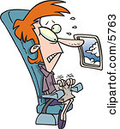  How often does she travel by plane? (never)  ______________________  ______________________  ______________________ | How often do they walk their dog? (every day)  ______________________  ______________________  ______________________

Answer Key
- Jim goes snowshoeing three times a year.
- Bill goes zorbing hardly ever.
- I never go snowshoeing.
- She always hangs out with her friends.
- She reads stories every night.
- They usually paint pictures.
- It often rains in Rize.
- They sometimes eat out.
- Oliver plays tennis once a week.
- I get up early 5 times a week.
- She never travels by plane.
- They walk their dog every day.

