5th Grades- Unit 6: MOVIES Vocabulary Exercises
Name/ Sur name:
1. What kind/ type of a movie is it?
c __ __ t __ __ n a __ i __ __ t i __ __ __ __ t i o __
w __ __ a d __ __ n __ u __ __ h __ __ __ o __
w __ s __ e __ __ s __ __ __ n __ e- f __ __ t i __ n
2. Match.
1. cartoon _____ A. macera 1. horror _____ A. bilim kurgu
2. animation _____ B. dram 2. war _____ B. korku
3. adventure _____ C. çizgi film 3. western _____ C. belgesel
4. action _____ D. animasyon 4. science- fiction _____ D. vahşi batı, kovboy
5. drama _____ E. macera 5. documentary _____ E. savaş
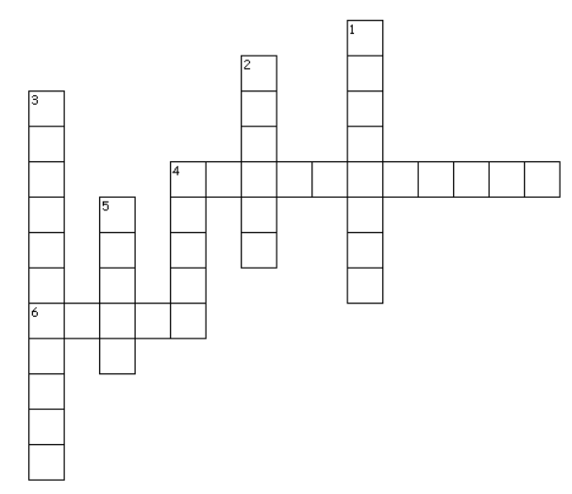
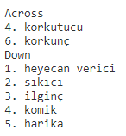
3. Do the criss- cross.

4. Answer the questions.
Ice Age 3 – Sid, Diego – Beykoz Movie Theatre – on Sunday – 4 p.m - animation
What type/ kind of a movie is it? _____________ Who are the characters? _______________________
Where is it on? ______________________________ What’s the name of the movie? _________________
When is it on? ______________________________ What time is it? _____________________________

5. Fill in the blanks.
I like ______________ movies because space is exciting.
I don’t like _______________ movie because it is scary.
I love _____________ movies. My favourite one is Tom and Jerry. Burçin BAYDAŞ
I enjoy _________________ movie. I think, it is funny. Elt Teacher
6. Match.
lazy – hardworking- strong- funny- handsome – beautiful- evil – helpful

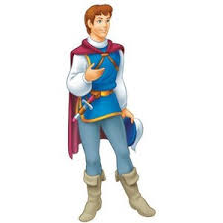
___________________ ____________ ________________ ____________

___________________ _____________ ________________ _____________

harika korkunç

heyecan verici sıkıcı

güçlü ilginç

korkutucu

yardımsever çalışkan

zeki komik kötü kalpli

Burçin BAYDAŞ
ELT

