Unit 1 Life Word List

A few beans :bir kaç tane fasülye
After × Before :Sonra ×Önce
After school:okuldan sonra
Arrive home :eve varmak
Assignment:ödev
At noon :öğlen
At the end of :sonunda
Attend a course:kursa katılmak
Aunt :teyze,hala
Best friend :en yakın arkadaş
Board games:tahta oyunları
Bring : getirmek
Celebrate :kutlamak
Classical music concert:klasik müzik konseri
Come back from school :okuldan dönmek
Date :tarih
Describe:tanımlamak
Do cleaning :temizlik yapmak
Do homework :ödev yapmak
Do jogging : tempolu koşu yapmak
Do sports :spor yapmak
Do the ironing :ütü yapmak
Draw:çizmek
Early× late :erken ×geç
Every lesson :her ders
Finish :bitirmek
Folk dance course:halk oyunları kursu
Get up :kalkmak
Go back : geri gitmek
Go to school :okula gitmek
Go to finish :bitişe git
Grandparents:büyükanne –baba
Have :sahip olmak
Have breakfast:kahvaltı yapmak
Have dinner :akşam yemeği yapmak
Have lunch :öğle yemeği yemek
In the evenings:akşamları
In the mornings:sabahları
Invatition card :davetiye
Leave home :evden ayrılmak
Little brother :küçük erkek kardeş
Life:yaşam
Listen :dinlemek
Lucky you !: Ne kadar şanslısın !
Make breakfast :kahvaltı yapmak
Meet :buluşmak
Month :ay
New words :yeni kelimeler
People :insanlar
Plan :planlamak
Play football:futbol oynamak
Play games:oyunlar oynamak
Play volleyball :voleybol oynamak
Play with friends :arkadaşlarla oynamak
Please join us :Lütfen bize katılın
For 6th Grade

Prepare :hazırlamak
Regular activities:düzenli aktivitiler
Relative :akraba
Rest :dinlenmek
Ride a bicycle :bisiklete binmek
Run errands :ev işi yapmak
Self –assessment :kendini değerlendirme
Skip :atlamak
Space: boşluk
Start:başlamak
Stick :yapıştırmak
Study :ders çalışmak
Swim :yüzmek
Take a course: kurs almak
Take a nap:şekerleme yapmak
Take care of the flowers :çiçeklerle ilgilenmek
Take care of the plants : bitkilerle ilgilenmek
Take the dog for a walk :köpeği yürüyüşe çıkarmak
Tea party:çay partisi
Tell the date :tarihi söylemek
Tell the time :zamanı söylemek
Throw the bean :fasülyeyi at
Time :zaman
Traditional :geleneksel
Uncle :amca ,dayı
Understand :anlamak
Visit :ziyaret etmek
Visual dictionary :görsel sözlük
Year :yıl
Wait:beklemek
Walk to school :okula yürüyerek gitmek
Wake up :uyanmak
Wash the clothes :çamaşır yıkamak
Watch TV:televizyon izlemek
Weekday :hafta içi
Weekend :hafta sonu
Wedding ceremony :düğün
Write :yazmak
Wrong questions &answers : yanlış sorular & cevaplar

FUNCTIONS

DAYS | MONTHS
Monday:Pazartesi  Tuesday :Salı  Wednesday :Çarşamba  Thursday :Perşembe  Friday :Cuma  Saturday :Cumartesi  Sunday :Pazar | 1-January :Ocak 7-July :Temmuz  2-February :Şubat 8-August :Ağustos  3-March :Mart 9-September :Eylül  4-April :Nisan 10-October :Ekim  5-May :Mayıs 11-November :Kasım  6-June: Haziran 12-December :Aralık

ORDINAL NUMBERS
- first  - second  - third  - fourth  - fifth  - sixth  - seventh  - eighth  - ninth  - tenth | 1st  2nd  3rd  4th  5th  6th  7th  8th  9th  10th | - eleventh  - twelfth  - thirteenth  - fourteenth  - fifteenth  - sixteenth  - seventeenth  - eighteenth  - nineteenth  - twentieth | 11th  12th  13th  14th  15th  16th  17th  18th  19th  20th | - twenty-first  - twenty-second  - twenty-third  - twenty –fourth  - twenty-fifth  - twenty-sixth  - twenty-seventh  - twenty-eighth  - twenty-ninth  - thirtieth  - thirty-first | 21st  22nd  23rd  24th  25th  26th  27th  28th  29th  30th  31st
● ‘S ( İsim tamlaması oluştururken “s “ kullanılır. “-ın ,-in “ eki anlamındadır.)

Jack’s birthday( Jack’in doğum günü ) e.g:Jack’sbirthday is on 1st April.(Jack’in doğum günü Nisan’ın 1’inde.)
Susan’scake(Susan’ın pastası ) e.g: Susan’scake is delicious . ( Susan’ın pastası lezzetli.)

A: When is David ‘sbirthday ?( David’in doğum günü ne zaman?)
B: His birthday is on 1st July. ( Onun doğum günü Temmuz’un 1’inde.)

A: When is Mary ‘sbirthday ?( Mary ’in doğum günü ne zaman?)
B: Her birthday is on 21st August . ( Onun doğum günü Ağustos’un 21’inde.)

● DATES

-We use “on “ before days.(Günlerden önce “on” kullanılır.)
I go to the cinema with my friends on Sundays.

-We use “in“ before months(Aylardan önce “in” kullanılır.)
We go on holiday in July.

-We use “in “ before years (Yıllardan önce “in” kullanılır.)
I was born in 2005.

-We use “on “ before dates.(Tarihlerden önce “on” kullanılır.)

My brother was born on 5th March ,1987.
My brother was born on the 5th of March ,1987.
My brother was born on the fifth of March ,1987.
My brother was born on the fifth of March,nineteen eighty-seven.

● TELLING THE TIME

We use this question “ What time is it? / What is the time ? ” by asking the time.

O’CLOCK  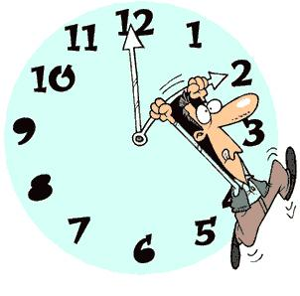  It is two o’clock . | HALF PAST  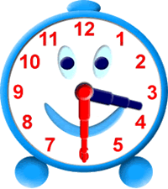  It is half past three  It is three ,thirty | QUARTER PAST  It is a quarter past ten  It is ten ,fifteen .
PAST  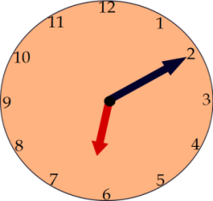  It is ten past six.  It is six,ten. | QUARTER TO  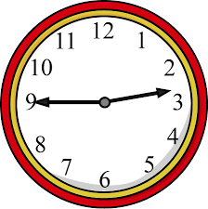  It is a quarter to three.  It is two ,forty-five. | TO  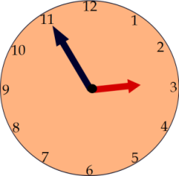  It is five to three .  It is two ,fifteen .

a.m. = ante meridiem (before noon)
p.m. = post meridiem (after noon)

THE SIMPLE PRESENT TENSE
( Geniş Zaman )
● USAGE ( kullanımı)

-We use this tense while talking about daily routines ,habits and activities done everyday.
( Günlük yapılan işleri ,alışkanlıkları ve her zaman yapılan aktivitileri anlatırken kullanılır.)

Examples :

I wake up at seven o’clock in the mornings . ( daily routine)
I take a nap after school.( habit)
I take care of my cat everyday .( activity done everyday)

-We use this tense while talking about likes and dislikes .
( Sevdiğimiz ve sevmediğimiz şeyler hakkında konuşurken kullanılır.)

Examples:

I like playing football at the weekend ( like )
I don’t like running errands. ( dislike )

● FORM

- Affirmative Sentence - Negative Sentence
( Olumlu cümle ) ( Olumsuz cümle )

I  You  We  They | have breakfast at 8 o’clock  study English everyday.  go to step dance course on Fridays.  visit their grandmother at the weekend.
He  She  It | drinks tea in the evenings .  goes shopping at the weekend  eats a banana everyday.
I  You  We  They | don’t help my mom  don’t take English course  don’t go to bed late  don’t go to school | in the evenings.  everyday.  at nights.  at the weekend.
He  She  It | doesn’t take care of his dog  doesn’t have breakfast  doesn’t like swimming | in the morning.  on the weekdays.  everyday

Note: Özne “I , you , we , they “ ise fiil yalın halde Note : Özne “ I ,you ,we ,they “ ise olumsuz cümlede
kullanılır.Eğer özne “ he,she ,it “ ise fiil “-s,–es,-ies“ don’t ,eğer özne “ he-she –it “ ise doesn’t kullanılır.
takısı alır.

- Interrogate sentence (Soru cümlesi )

Do | I  You  We  They | brush my teeth everyday ?  have lunch at school?  do homework every evening ?  go to the cinema on Sundays ? | Answers  Yes, you do.  Yes,I do.  Yes,you do.  No ,they don’t .
Does | He  She  It | play football at the school garden ?  eat fruits everyday?  climb a tree? | Yes,he does.  No,she doesn’t.  Yes,it does.

Note: Özne “ I,you,we ,they “ ise cümlenin başında “ do “ ,eğer özne “he,she,it “ ise “does”kullanılır.

● SPELLING RULES ( Heceleme kuralları)

- Çoğu fiil “–s “ takısı alır .

My mother cooks delicious meal.
She comes home at 9:00 p.m in the evenings.

- “-ch,- sh,- ss, - o “ ile biten filler “es” takısı alır.

My brother watches TV every morning.
My school finishes at half past four.
Julia goes to traditional folk dance class every Saturday.

- Fiil “-y” ile bitiyorsa ve “-y “ den önce sessiz bir harf varsa “ y “ düşer ve fiile “-ies “ takısı eklenir.

Cansu studies English everyday. study – studies
Our baby cries every night. cry - cries

- “have “ fiili düzensizdir. “s” takısı aldığında have “ has “ olarak yazılır.
Prepared by

I have breakfast every morning.
She has breakfast every morning.

