6. SINIF – YABANCI DİL
1-Aşağıdakilerden hangisi diğerlerinden farklıdır?
“ tea / coffee / olives / orange juice ”

a-tea b- coffee c- olives d- orange juice
2- Boşluğa aşağıdakilerden hangisi gelmelidir?
A:How many …………………..are there ?
B: There are a lot

a-honey b- tomatoes c-cheese d- jam
3- A: How much …………………..is there?
B: There isn’t any.

a- bagel b-water c- cucumber d-egg
4- A: How many potatoes are there ?
B:There aren’t …………….potatoes .

a-some b- a lot of c- a little d-any

5- Hans: …………………do you get home?
Julie : I get home at half past four.

a-Which b- What time c- How many d- How

6 - I like eating …………. My favourite is cucumber.

a-chicken b- fish c- vegetables d-chips

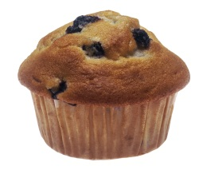
7. I have - - - - at breakfast.
a) cheese b) croissants
c) muffin d) bread

8. Yiyeceklerin doğru sıralanmış hali hangisidir?
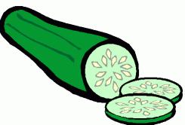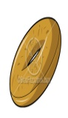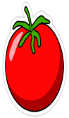
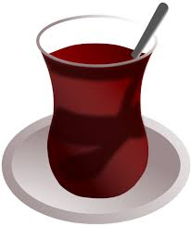
- Cheese – tomato – potato
- Cucumber – bagel – tomato
- Cucumber – tomato – bagel
- Carrot – croissants – tomato

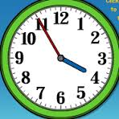
9- What time is it?
- It’s four o’clock.
- It’s five to four.
- It’s five past four.
- It’s half past five.
10 – What does he do everyday?
- He has lunch.
- He has dinner.
- He has got sister.
- He has breakfast.

